***Getting Started (Admin)***

“ Python manage.py createsuperuser “ Enables you to create a master admin account.

When creating the superuser, leave the department,directorate and role fields blank.

***Creating User Accounts***

Register all users through using either the system registration form or through the admin. Bear in mind that for all users that fall under the bracket of Line Manager, Director or Executive Director you shall be required to go into the admin of the system and manually modify their accounts to give them privileges on the system.

This entails checking the box “is staff” so that the system knows that the user can make modifications to leave requests. Second, you should check a box depending on whether the account holder is regarded as a line manager, director or executive director. The example below is for a user that is a director.

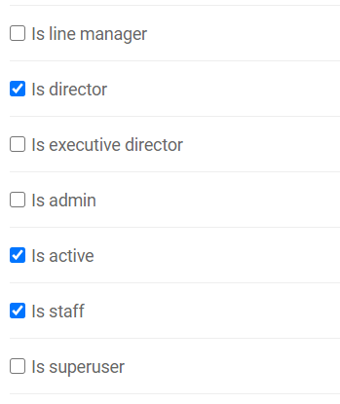

For the executive director the “is admin” box should be checked as well so that it ends up looking like this:

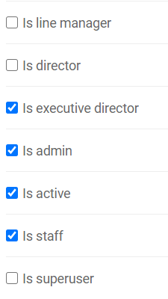

***Organising the Accounts***

All departments, directorates, HR staff, line managers, directors and executive director shall be required to be defined in their respective lists in the AdminDashboard section of the Django admin panel:

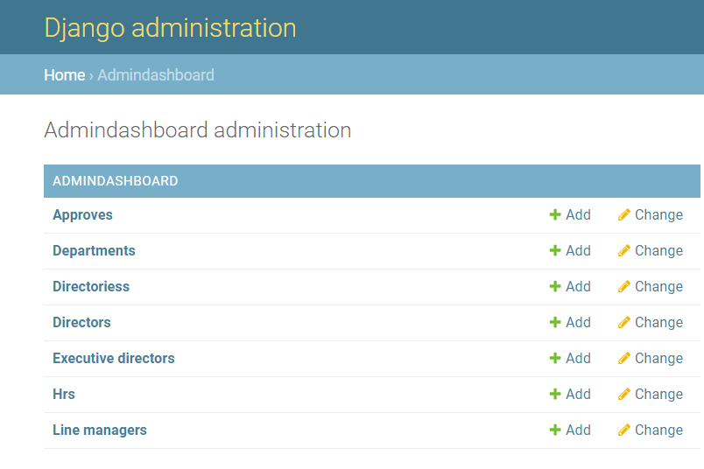

The “Directories” list should be filled out first followed by the list of “Departments”. The rest of the lists can be filled out in any order. The “Approves” list can be ignored.

\*\***NOTE:** It is imperative that the spelling of all departments, directorates, HR staff, line managers, directors and executive director is consistent with the spellings used in the creation of the User Accounts. Any spelling mistake will cause an error in the system as the information will not match up.**